

SOUTH EAST ASIAN INSTITUTE OF TECHNOLOGY, INC.

National Highway, Crossing Rubber, Tupi, South Cotabato

**COLLEGE OF INFORMATION AND COMMUNICATION TECHNOLOGY**

___________________________________________________

**LEARNING MODULE**

**FOR**

**IT 123: WEB DEVELOPMENT 1**

**_____________________________________________________**

***WEEK 10***

**COURSE OUTLINE**

**COURSE CODE**  : IT 123

**TITLE**  : Web Development 1

**TARGET POPULATION** : All BS Information Technology Students

**INSTRUCTOR** : MS. CAROL KATE M. ESTACIO

**Overview:**

HTML stands for Hypertext Markup Language, and it is the most widely used language to write Web Pages.

• Hypertext refers to the way in which Web pages (HTML documents) are linked together. Thus, the link available on a webpage is called Hypertext.

• As its name suggests, HTML is a Markup Language which means you use HTML to simply "mark-up" a text document with tags that tell a Web browser how to structure it to display.

Originally, HTML was developed with the intent of defining the structure of documents like headings, paragraphs, lists, and so forth to facilitate the sharing of scientific information between researchers.

Now, HTML is being widely used to format web pages with the help of different tags available in HTML language.

**Content:**

**CSS**

* + **What CSS does**
  + **How CSS works**
  + **3 Ways to Insert CSS**
  + **CSS Syntax and Selectors**

**Objectives:**

General Objective

* + Introduce you to how CSS works
  + Teach you how to write CSS
  + Introduce the different usage of selectors

**Instruction to the Learner**

Each chapter in this module contains a major lesson involving the basics of Web page coding and HTML editing tool. The units are characterized by continuity, and are arranged in such a manner that the present unit is related to the next unit. For this reason, you are advised to read this module. After each unit, there are exercises to be given. Submission of task given will be every Monday during your scheduled class hour.

**Styling HTML with CSS**

CSS stands for Cascading Style Sheets. CSS is a stylesheet language that describes the presentation of an HTML document. CSS describes how elements must be rendered on screen, on paper, or in other media.

Styling can be added HTML elements 3 ways:

* Inline – using a style attribute in HTML elements
* Internal – using a <style> element in the HTML <head> section
* External – using one or more external CSS files.

CSS Syntax

A CSS rule-set consists of a selector and a declaration block:

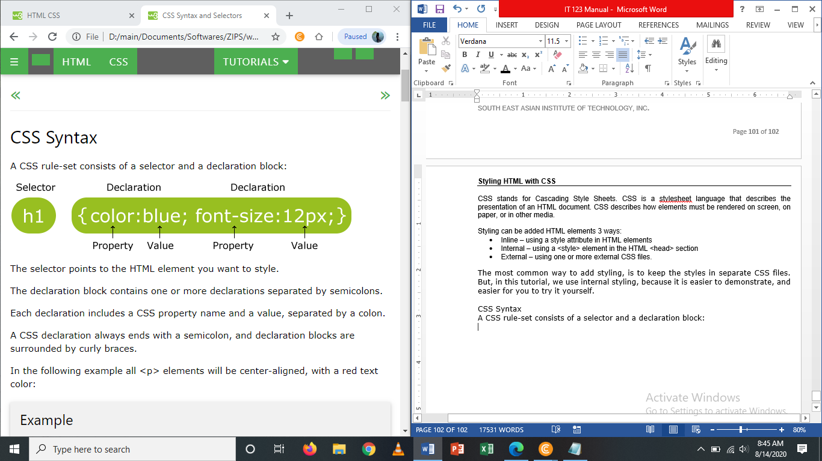

The selector points to the HTML element you want to style. The declaration block contains one or more declarations separated by semicolons. Each declaration includes a CSS property name and a value, separated by a colon. A CSS declaration always ends with a semicolon, and declaration blocks are surrounded by curly braces.

**The Element Selector**

The element selector selects elements based on the element name.

You can select all <p> elements on a page like this (in this case, all <p> elements will be center-aligned, with a red text color):

**Example**

p {  
    text-align: center;  
    color: red;  
}

**The ID Selector**

The id selector uses the id attribute of an HTML element to select a specific element.

The id of an element should be unique within a page, so the id selector is used to select one unique element!

To select an element with a specific id, write a hash (#) character, followed by the id of the element.

The style rule below will be applied to the HTML element with id="para1":

**Example**

#para1 {  
    text-align: center;  
    color: red;  
}

*Note: An id name cannot start with a number.*

**The class Selector**

The class selector selects elements with a specific class attribute.

To select elements with a specific class, write a period (.) character, followed by the name of the class.

In the example below, all HTML elements with class="center" will be red and center-aligned:

Example

.center {  
    text-align: center;  
    color: red;  
}

You can also specify that only specific HTML elements should be affected by a class.

In the example below, only <p> elements with class=”center” will be center-aligned:

Example

p.center {  
    text-align: center;  
    color: red;  
}

HTML elements can also refer to more than one class.

In the example below, the <p> element will be styled according to class=”center” and to class=”large”:

Example

<p class="center large">This paragraph refers to two classes.</p>

**Grouping Selectors**

If you have elements with the same style definitions, like this:

h1 {  
    text-align: center;  
    color: red;  
}  
  
h2 {  
    text-align: center;  
    color: red;  
}  
  
p {  
    text-align: center;  
    color: red;  
}

It will be better to group the selectors, to minimize the code. To group selectors, separate each selector with a comma (,). In the example below we have grouped the selectors from the code above:

Example

h1, h2, p {  
    text-align: center;  
    color: red;  
}

**CSS Comments**

Comments are used to explain the code, and may help when you edit the source code at a later date. Comments are ignored by browsers.

A CSS comment starts with /* and ends with */. Comments can also span multiple lines:

Example

p {  
    color: red;  
    /* This is a single-line comment */  
    text-align: center;  
}  
/* This is  
a multi-line  
comment */

**Three (3) Ways to Insert CSS**

There are 3 ways to insert CSS

* External style sheet
* Internal style sheet
* Inline style sheet

***External Style Sheet***

With an external style sheet, you can change the look of an entire website by changing just one file. Each page must include a reference to the external style sheet file inside the <link> element. The <link> element goes inside the <head> section:

**Example**

<head>  
<link rel="stylesheet" type="text/css" href="mystyle.css">  
</head>

An external style sheet can be written in any text editor. The file should not contain any html tags. The style sheet must be saved with a .css extension.

Here is how the “myStyle.css” looks:

body {  
    background-color: lightblue;  
}  
h1 {  
    color: navy;  
    margin-left: 20px;  
}

*Note: Do not add a space between the property value and the unit (such as margin-left: 20 px;). The correct way is: margin-left:20px;*

***Internal Style Sheet***

An internal style sheet may be used if one single page has a unique style.

Internal styles are defined within the <style> element, inside the <head> section of an HTML page:

Example

<head>  
<style>  
body {  
    background-color: linen;  
}  
  
h1 {  
    color: maroon;  
    margin-left: 40px;  
}  
</style>  
</head>

***Inline Styles***

An inline style may be used to apply a unique style for a single element. To use inline styles, add the style attribute to the relevant element. The style attribute can contain any CSS property. The example below shows how to change the color and the left margin of a <h1> element:

Example

<h1 style="color:blue;margin-left:30px;">This is a heading.</h1>

*Note: An inline style loses many of the advantages of a style sheet (by mixing content with presentation). Use this method sparingly.*

***Multiple Style Sheets***

If some properties have been defined for the same selector (element) in different style sheets, the value from the last read style sheet will be used.

Example

Assume that can external style sheet has the following style for the <h1> element:

h1 {  
    color: navy;  
}

Then, assume that an internal style sheet also has the following style for the <h1> element:

h1 {  
    color: navy;  
}

If the internal style is defined after the link to the external style sheet, the <h1> elements will be "orange":

Example

<head>  
<link rel="stylesheet" type="text/css" href="mystyle.css">  
<style>  
h1 {  
    color: orange;  
}  
</style>  
</head>

However, if the internal style is defined before the link to the external style sheet, the <h1> elements will be "navy":

Example

<head>  
<style>  
h1 {  
    color: orange;  
}  
</style>  
<link rel="stylesheet" type="text/css" href="mystyle.css">  
</head>

**Challenge**

1. Create a new HTML file. (for external CSS)
2. And save it as “myStyle.css”
3. On your existing HTML file (AboutMyself.html) insert this CSS link inside the <head> tag “<link rel=”stylesheet” type=”text/css” href=”myStyle.css”/>”